Matching: Match each term with the correct definition.

- Martin Luther
- Simon Bolivar
- Louis XIV
- Hernando Cortez
- Alexander the Great

- Karl Marx
- Otto von Bismarck
- Toussaint L’Overture
- Genghis Khan
- John Locke

- monotheistic
- social hierarchy
- patriarchal

- secular
- totalitarianism

Multiple Choice: Chose the letter that best answers the question.
- “If the seignior [noble] has knocked out the tooth of a seignior of his own rank, they shall knock out his tooth. But if he has knocked out a commoner’s tooth, he shall pay one-third mina of silver.”
- Code of Hammurabi

Which idea of Babylonian society does this portion of the Hammurabi Code of law reflect?

- The combination of religious and political authority in Ancient Egypt my be described as

- Which of the following choices has the civilization correctly matched with their writing system?
Sumerians (Mesopotamia) - ?, Phoenicians - ?, Egyptians - ?

- Which civilization developed the concept of the “Mandate of Heaven?

- Confucius believed that social order, harmony, and good government could be achieved if society was organized around five basic

- The Qu’ran, jihad, and the hijrah are most closely associated with the practice of

- The most practiced religion in India is

- Who was the great Mauryan ruler who conquered India and spread Buddhism?

- This Greek philosopher taught by persistent questioning. He was eventually put to death for questioning the government. Who is it?

- Which political system had its foundations in Athens?

- Hellenistic culture represented a blending of Greek culture with all of the following cultures EXCEPT:

- The Pax Romana is best described as:

- In what way was the Roman political system different from the Greek political system in Athens?

- Spartan society was famous for

- The government of early Rome (approximately the first 500 years) can best be described as a

- Julius Caesar

- All of the following can be said of Jesus EXCEPT that he

- Which of the following did Russia adopt from the Byzantines?

- One similarity between the Five Pillars of Islam and the Ten Commandments is that both

- Which heading best completes the partial outline below?
- _____________________________________
  - Development of medical encyclopedias
  - Development of algebra and astronomical tables
  - Production of woolen carpets
  - Production of literature, calligraphy, and geometric art

- The growth of feudalism in Europe during the Middle Ages was primarily caused by the

- The Middle Ages in Western Europe was characterized by

- In Europe during the Middle Ages, the institution that provided unification and stability was the

- In Europe, a long term effect of the Crusades was

- A major goal of the Christian Church during the Crusades was to

- In early African societies, people incorporated elements of a religion in which spirits play an important role in regulating daily life into their spirituality. The religion is called

- Bantu is a language native to

- The Five Pillars of Islam contain all of the following EXCEPT

- Ibn Battuta and Marco Polo were similar in that both

- European society during the Renaissance differed from European society during the Middle Ages in that during the Renaissance

- The Renaissance and the Protestant Reformation were similar in that both were

- In Western Europe, a major immediate effect of the Reformation was a

- Which was a major result of the Reformation?

- One reason the Spanish conquistadors were able to conquer the Aztec and Inca empires rapidly is that

- In Latin America during the early period of Spanish colonialism, the deaths of large numbers of native people led to

- According to the theory of mercantilism, colonies should be

- The global transfer of foods, plants, animals, and diseases during the colonization of America’s is known as the

- During the Age of Absolutism (1600’s and 1700’s) European monarchs tried to

- Westernization in Russia came about largely through the

Base your answer to the following questions on the statements below and your knowledge of social studies.

- Which two speakers would support absolutism? (know Absolutism & Divine Right Theory)

- Which statement best describes the effects of the works of Nicolas Copernicus, Galileo Galilee, Sir Isaac Newton, and René Descartes?

- During the Scientific Revolution and the Enlightenment, one similarity in the work of many scientists and philosophers was that they (what was similar in beliefs and methods?)

- Philosophers of the Enlightenment period believed that society could best be improved by

Base your answer to the following questions on the statements below and your knowledge of social studies.

- Which speaker’s statement best reflects the ideas of the Enlightenment?
(know the Enlightenment thinkers Locke, Voltaire, Rousseau, Montesquieu, and what ideas they expressed)

- Which statement is a valid generalization about the immediate results of the French Revolution of 1789?

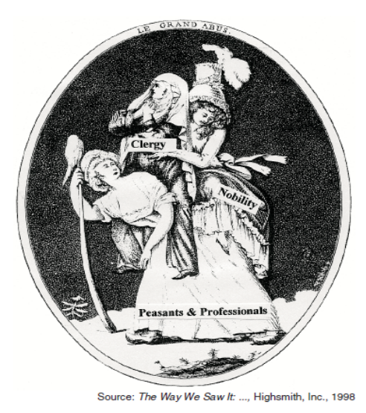
Base your answers to this question on the drawing below and your knowledge of social studies.

- This drawing illustrates conditions that contributed primarily to the beginning of the

- Which conclusion can be drawn from this drawing?

- The Napoleonic Code

- During the early 1800’s, which was a major influence on the struggle for political independence in Latin America?

- Which of these situations was the direct result of the other three?
    - the Napoleonic wars weakened Spain’s power
    - nations of Latin America won independence
    - revolutions occurred in North America and France
    - creoles and mestizos became discontented with Spanish rule

- Nationalism is most likely to develop in an area that has

- Which condition is most necessary to the process of industrialization in a society?

- Before a nation can begin to industrialize, that nation must first develop

- A major result of the Industrial Revolution was the

- Adam Smith’s economic theory of laissez-faire capitalism proposes that

- A key principle of the economic theory of communism is

- After 1880, European nations sought colonies in Africa primarily because the Europeans were

- Which statement best expresses the Western perspective regarding Rudyard Kipling’s “White Man’s Burden”?

- One result of the Opium War was that China

- In the past, European nations have conquered other lands, made them into colonies, and controlled their economies.
Which term refers to the situation described in this statement?

- An immediate result of Commodore Matthew Perry’s visit to Japan in 1853 was

- In Japan, the Meiji Restoration resulted in the

- Which statement best describes the relationship between World War I and the Russian Revolution?

- A major cause of World War I was

- Which front during WWI was characterized by trench warfare?

- Which of the following new type of warfare was introduced in World War I?

- The Treaty of Versailles contributed to the economic instability in Germany after World War I by

- In the 1920’s and 1930’s, the rise of totalitarian governments in Germany, Italy, and Spain was largely the result of

- Fascism in Europe during the 1920’s and 1930’s is best described as a

- Which of the following men was not a fascist leader during World War II?

- Josef Stalin’s collective farms and Mao Zedong’s communes

- Which action illustrates the concept of genocide?

- One reason that Britain and France agreed to appease Hitler at the Munich Conference was to

- During World War II, which event occurred last?

"Gandhi Calls for Boycott of British Textiles"
"Gandhi and Followers Complete March to the Sea"
"Gandhi Begins Hunger Fast"

These headlines reflect Gandhi's belief in

- Which of the following is a method used by the United Nations to promote peace and cooperation among the nations that was unavailable to the League of Nations?

- Kwame Nkrumah and Jomo Kenyatta are most associated with

- Which of the following is NOT associated with McArthur’s plans for post-war Japan?

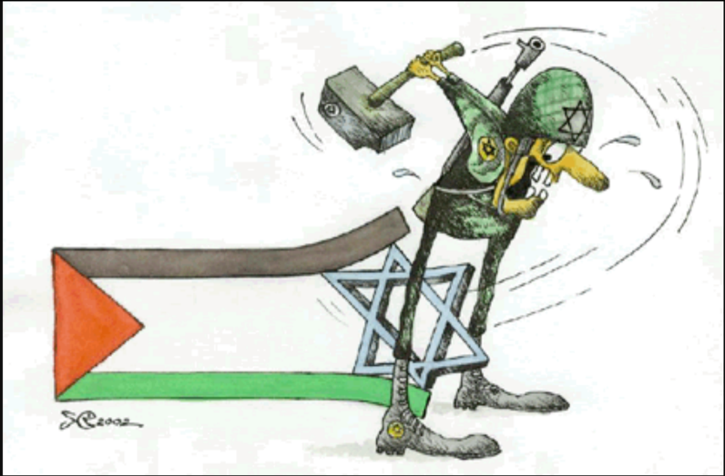
- Based on the cartoon, what conclusion can be drawn about the formation of the state of Israel?

- The Marshall Plan was designed to stop the spread of communism by providing

- Base your answer to the next question on the statement below and on your knowledge of social studies.

…The Parties agree that an armed attack against one or more of them in Europe or North America shall be considered an attack against them all and consequently they agree that, if such an armed attack occurs, each of them, in exercise of the right of individual or collective self-defence…will assist the Party or Parties so attacked by taking forthwith, individually and in concert with the other Parties, such action as it deems necessary, including the use of armed force, to restore and maintain the security of the…area…

Which organization includes this statement in its charter?

- The detonation of a hydrogen bomb by the US in 1952 was most responsible for

- The SALT Treaty

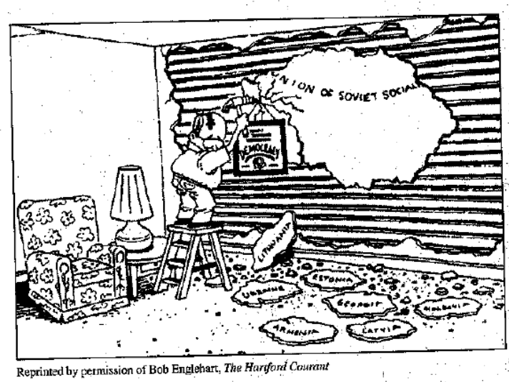
- Which of the following is most closely associated with the cartoon depicted?
(looking for the applicable leader and policy)

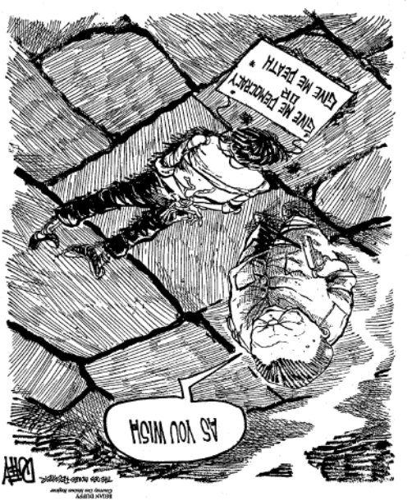
- According to the cartoon, how did the Chinese government respond to the events at Tiananmen Square in 1989?

