Honors World History
Mr. Merrill
email: heath.merrill@cobbk12.org

Overview: The goal is to help enlighten the students about the world around them, as to help them function in an ever increasing interdependent world. Therefore, this course emphasizes the historic, economic, geographic, political, and social structure of various cultural regions of the world from the dawn of civilization to twentieth century. Special attention is given to the formation and evolution of societies into complex political and economic systems.
Course Content:
Unit 1 The Rise of Civilizations in Asia, Africa, Americas and Europe
- River Valley Civilizations, Early Religions, and Ancient Kingdoms

Unit 2 New Empires Emerge
- Ancient Greece, Ancient Rome, Maurya and Gupta India, Qin and Han China

Unit 3 Transition to the Modern World
- Islam, Byzantines, Early Russia, Medieval Europe, West African Kingdoms, & East
African City States

Unit 4 Worlds Collide
- Maya, Aztec, Inca, Renaissance, Reformation, Exploration, Tokugawa Japan, & Ming
China

Unit 5 Revolution
- Absolutism, Enlightenment, Scientific Revolution; English, American, & French
Revolutions, & Nationalism

Unit 6 Change and Global Conflict
- Industrial Revolution, Imperialism, Meiji Restoration
Unit 7 The World at War
- World War I, Fascism, Nationalism, World War II,
Unit 8 Globalization: Interconnected and Interdependent
- Post War rebuilding, Cold War, Fall of the USSR, Arab Israeli Conflict, Indian
Independence, 20th C China, African Independence
Supplies:
- 3 ring binder with loose-leaf paper
- Pen / pencil
- Markers, Kleenex, and colored pencils are always needed. It would be great if you could help!
Rules:
- Students have no restrictions on bathroom use or food until they abuse the privilege. If abused the student or class (whichever is appropriate) will be placed on a temporary probation as determined by the teacher.
- Follow directions the first time they are given
- Speak and listen respectfully, using polite and appropriate language.
- Respect all persons; respect all property
- Bring all needed materials to class***
- No cell phones or ipods (unless allowed by teacher for lesson)
Consequences:
- First, students will be talked to after class.
- If behavior continues the student will receive lunch detention.
- The student will be given a referral if all attempts fail.
- Cell phones and ipods are contraband and will be dealt with according to school policy.

Communication with families: Email is the best way to contact me: heath.merrill@cobbk12.org

Grading:
Grades in this class will be calculated by percentages allocated to categories.
- Unit Exams…………………………………………………………………….…. 40%
- Writing Assignments……………………………………………………………. 10%
- Quizzes………………………………………………………………………...….. 15 %
- Project………………………………………………………………………………..5%
- Daily Formative Assessment/Warm Up/Homework…………………….... 15 %
- Final………………………………………………………..……………………….. 15 %

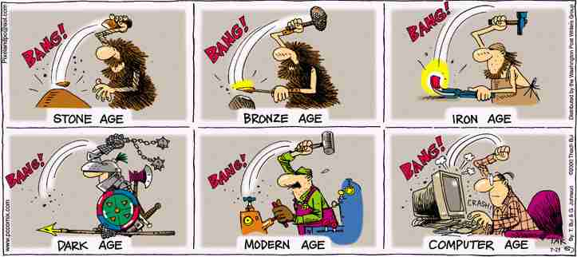A 100% - 90% B 89% - 80% C 79% - 74% D 73% - 70%

Common Questions:

- What is your policy on late work? Are all assignments allowed to be turned in late? What are the guidelines and/or penalties for turning in late work (points off each day, must be turned in within a week, etc.)?

A: All work is expected to be completed on the due date. If………
Work is handed in on time = maximum grade possible is 100%
Work is handed in late, but before the unit exam = maximum grade possible is 70%
Work is handed in after the unit is over = maximum grade possible is 50%

- Can textbooks be left at home?

A: Yes!

- What do I do if a miss an exam or quiz?

A: It is the student’s responsibility to schedule a make-up time with the teacher by the end of following unit. If it is not made up within the following unit the student will get a 0.

RATED R MOVIE PERMISSION
Various movies are shown in World History to expand upon various units of study in the class. Each movie provides a unique insight into the relevant topic and will help the students become engaged in the topic. However, some of the films are rated R. Many of the films are not shown in entirety, and all nudity is skipped over.

□ CHECK THE BOX IF YOU GIVE PERMISSION FOR YOUR CHILD TO VIEW RATED R MOVIES

(ALTERNATIVE ASSIGNMENTS WILL BE PROVIDED FOR THOSE WHO DO NOT HAVE PERMISSION TO VIEW)

Some of the movies include:
- Alexander
- The Last Samurai
- Saving Private Ryan
- Enemies at the Gate
- Charlie Wilson’s War

Should you have any questions regarding the movies please feel free to email me at: heath.merrill@cobbk12.org

Please complete the information below:

Student Name: ________________________________________________

Parent / Guardian Name (s) ______________________________________

Parent / Guardian Signature ______________________________________

Parent(s)/Guardian(s) email: __________________________________________

